AWS Task-3
Task Description:
- Create a S3 bucket, with no public access and upload files to the bucket & view the logs using cloud watch for the uploaded files.
- Launch two ec2-instances and connect it to a application load balancer, where the output traffic from the server must be an load balancer IP address

1. Create a S3 bucket, with no public access and upload files to the bucket & view the logs using cloud watch for the uploaded files.
Step 1: Create S3 Bucket
- Login to Amazon Web Services Console
- Search for S3 → Click Create bucket
- Enter:
  - Bucket name (must be globally unique)
  - Region (same as EC2 preferred)
- Under Block Public Access Settings:
  - Keep “Block all public access” ENABLED
- Click Create bucket
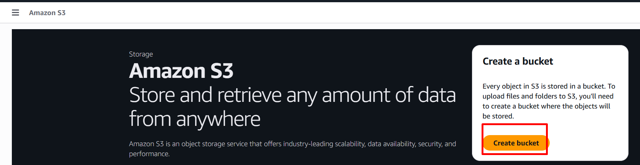
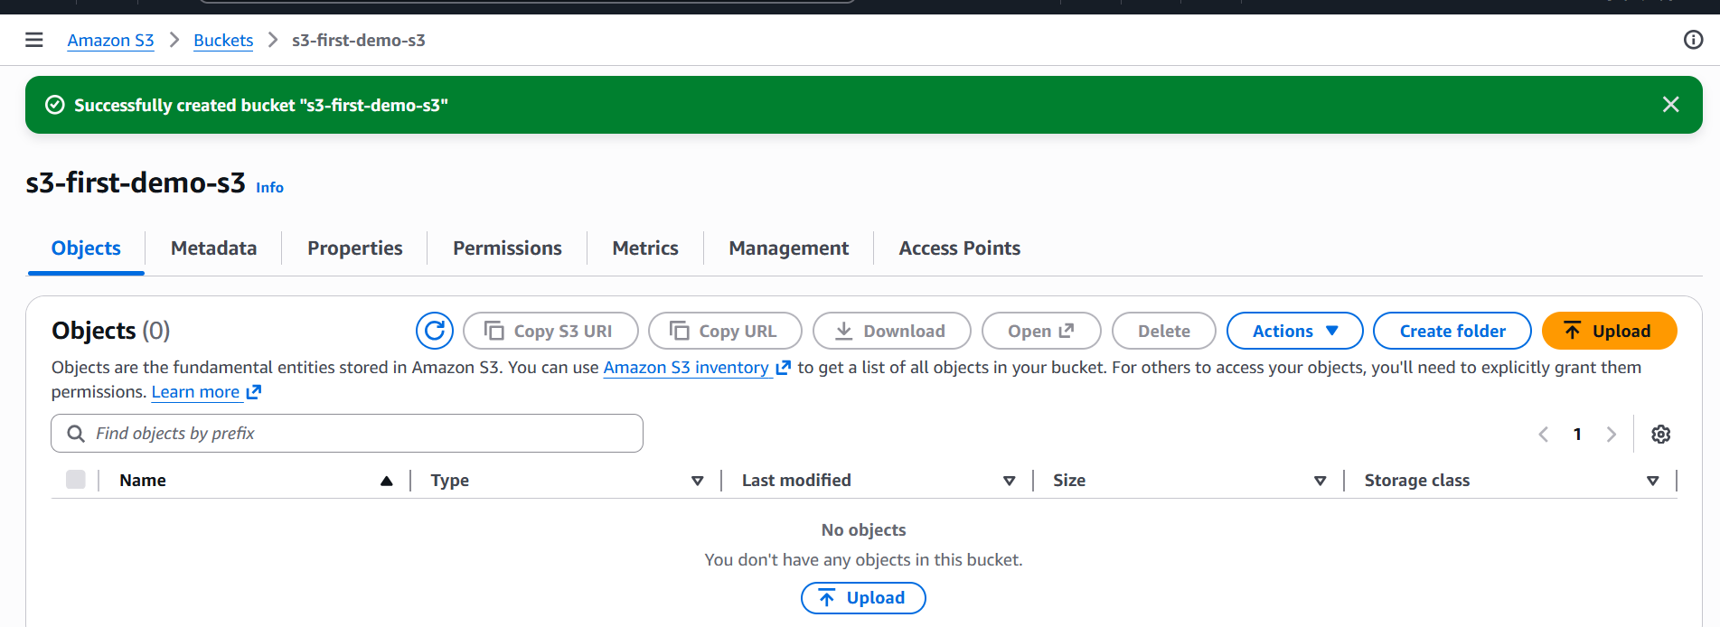

Step 2: Upload Files to S3
- Open the created bucket
- Click Upload
- Add files → Click Upload
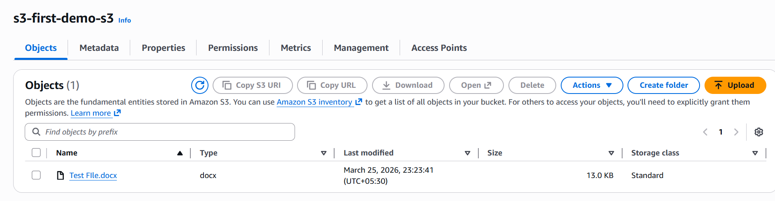
Step 3: Enable Logging (CloudTrail → CloudWatch)
To monitor S3 activity logs:
- Go to CloudTrail
- Click Create Trail
- Configure:
  - Trail name
  - Enable S3 Data Events
- Send logs to:
  - CloudWatch Logs Group
- Create or select IAM role
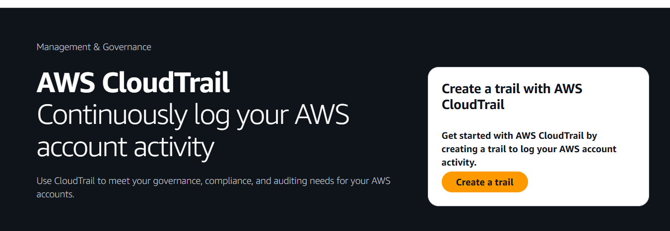
Step 4: View Logs in CloudWatch
- Go to Amazon CloudWatch
- Click Logs → Log Groups
- Select your log group
- View logs for:
  - File uploads
  - Access events
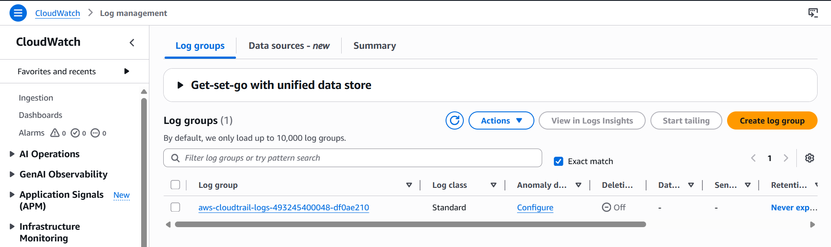

2. Launch two ec2-instances and connect it to a application load balancer, where the output traffic from the server must be an load balancer IP address
2.1. Launch two ec2-instances
- Go to EC2 → Launch Instance
- Choose:
• AMI: Amazon Linux / Ubuntu
• Instance type: t3.micro (free tier)
- Key pair: proceed without a key pair

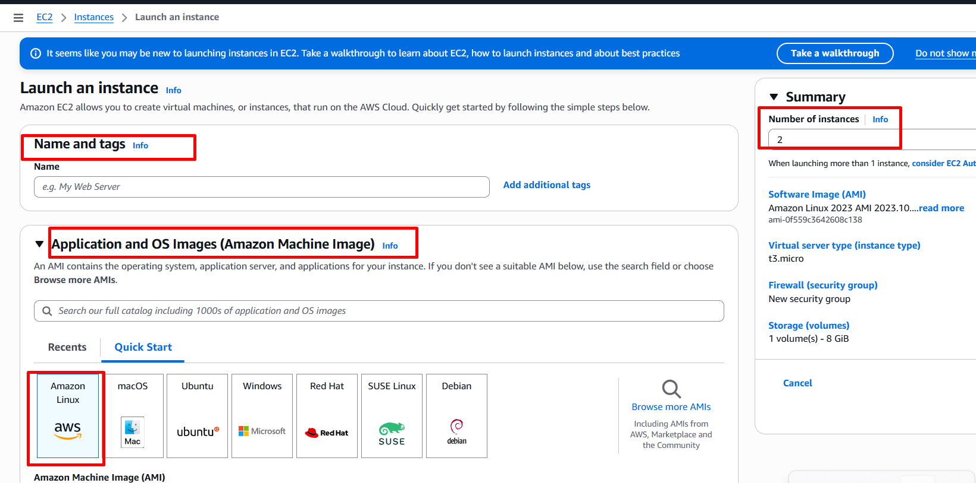
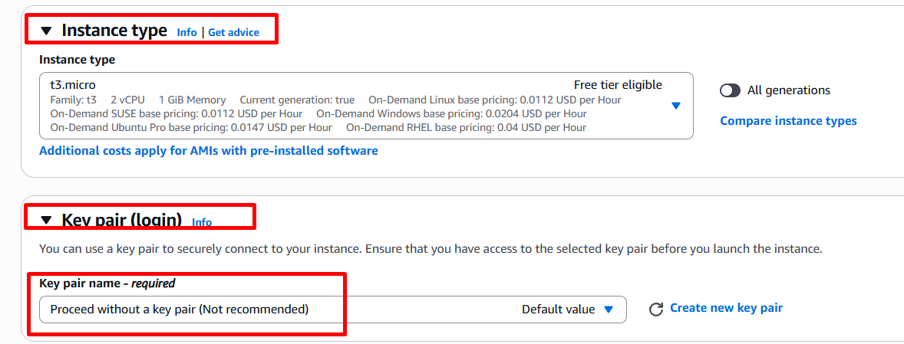
- Allow the Network setting: choose all traffic
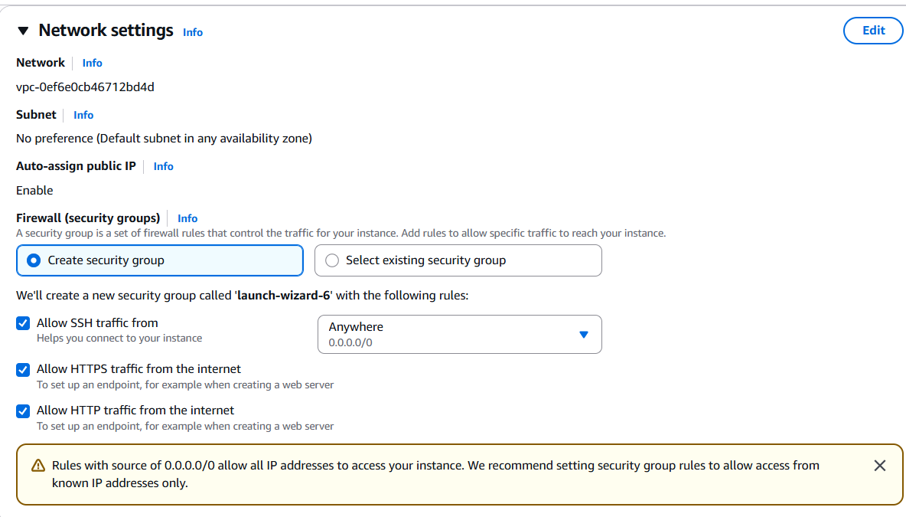
- Advanced details: User Data - put nginx command
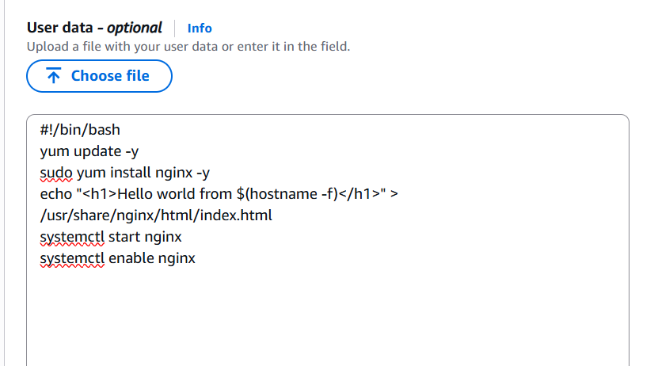
#!/bin/bash
yum update -y
yum install nginx -y
echo "<h1>Hello world from $(hostname -f)</h1>" > /usr/share/nginx/html/index.html
systemctl start nginx
systemctl enable nginx
- Launch 2 instances

Check the Public ip with the browser
http://<publicip> - http://13.232.233.53/ for the first instance

http://<publicip> - http://43.204.32.187/ for the Second instance

  - Connect these 2 instances with application load balancer:
- Load Balancers : Create the load balancer
- Create Application Load Balancer
- Basic configuration:
- Scheme: Internet-facing
- Availability Zone: choose all the zone
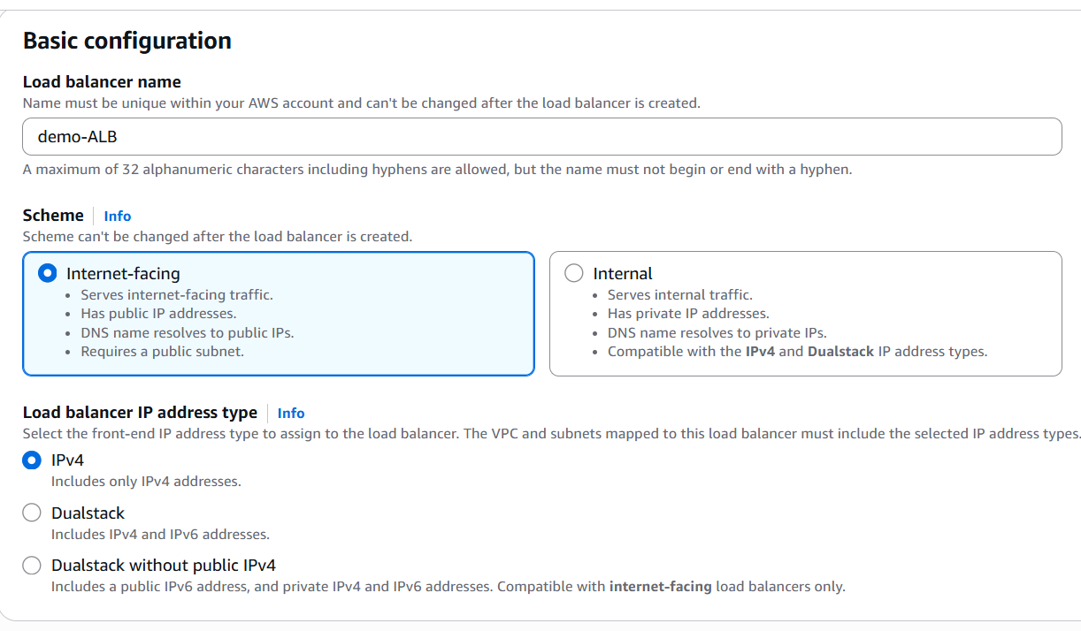
- Security groups: create new security group
- Security group name: demo-ALB-SG
- Description: test
- Inbound rules: put HTTP and HTTPS rules and make the source is 0.0.0.0/0
- Create the security group
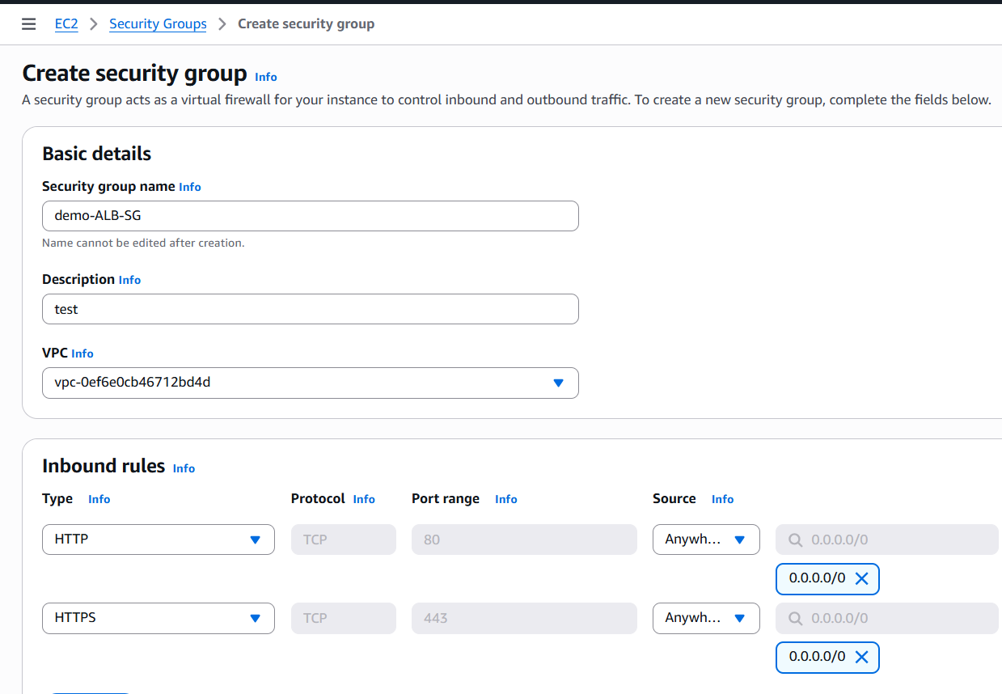
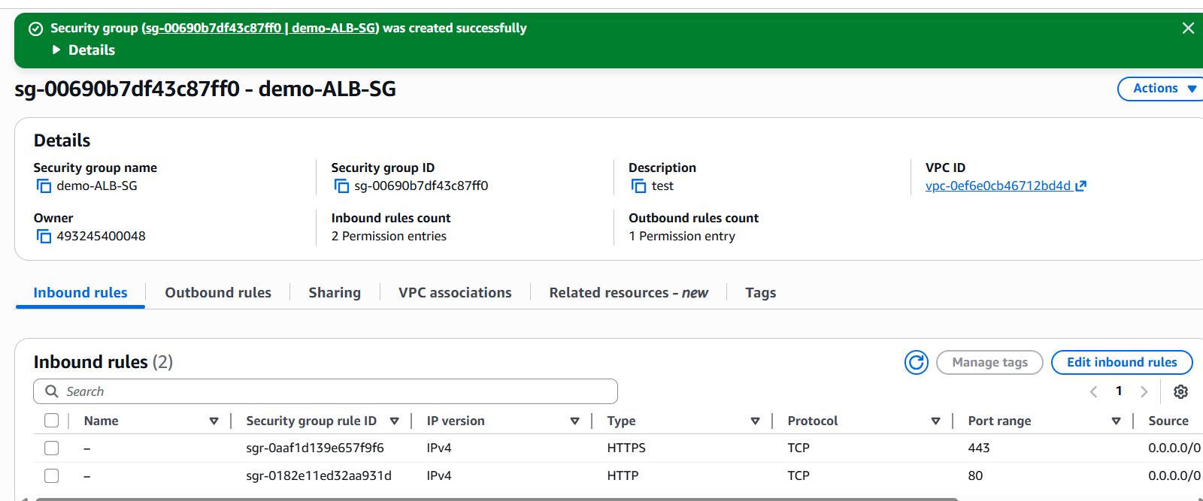

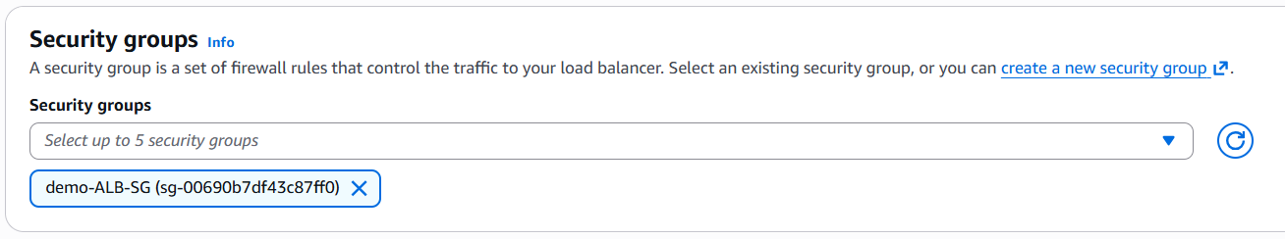
- Listeners and routing
- Create new Target group
- Target type: Instances
- Target Name: demo-TG
- Click next
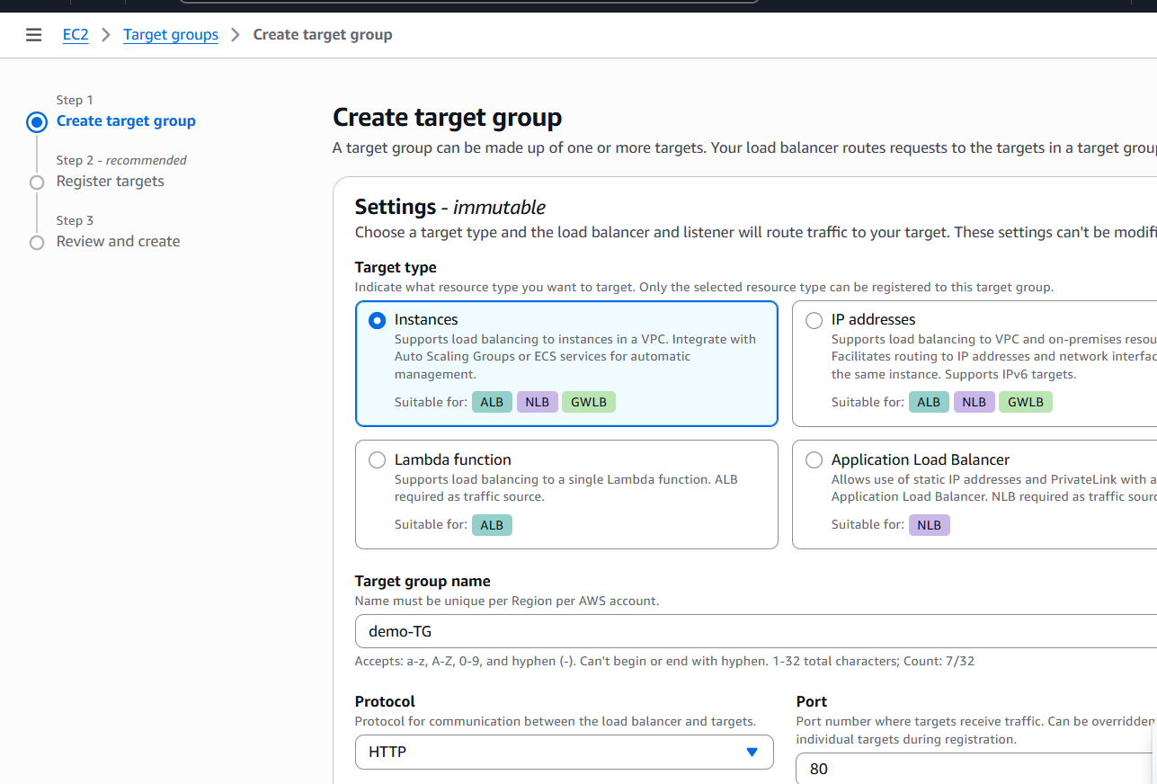

- Register targets – Select the both instance and click include as a pending below
- Create the Target group
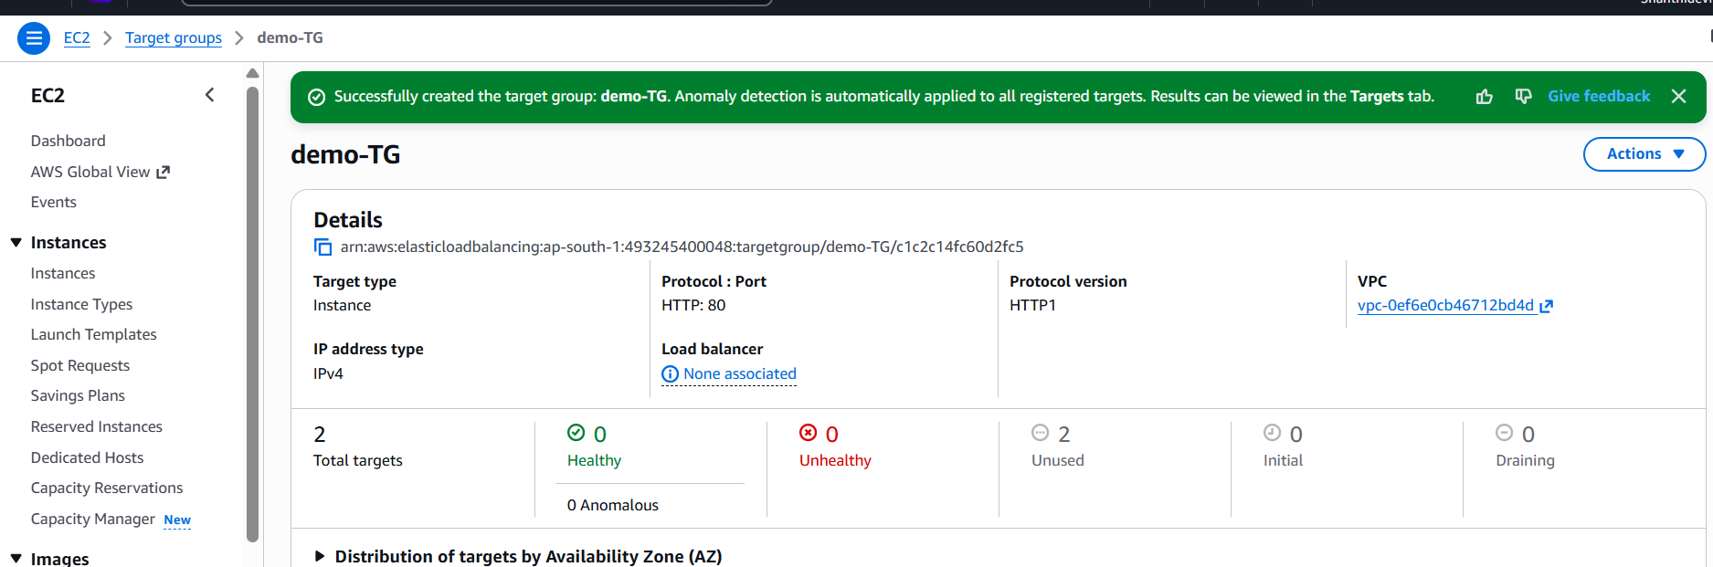
- Select the Target group
- Click - Create the load Balancer
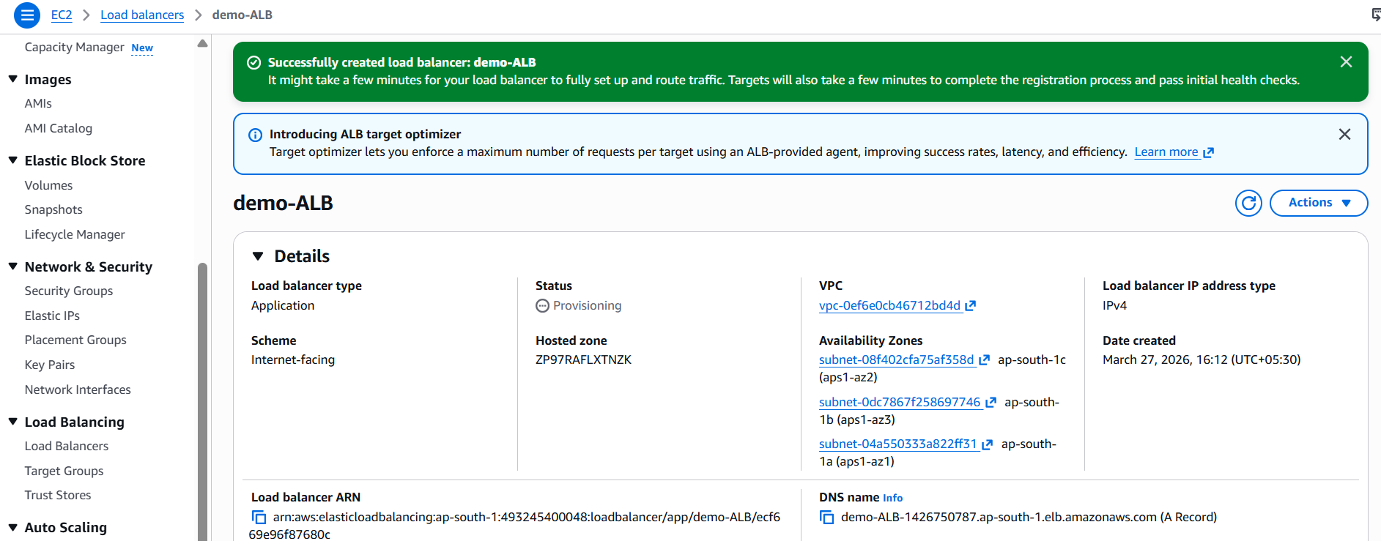

- Check the status
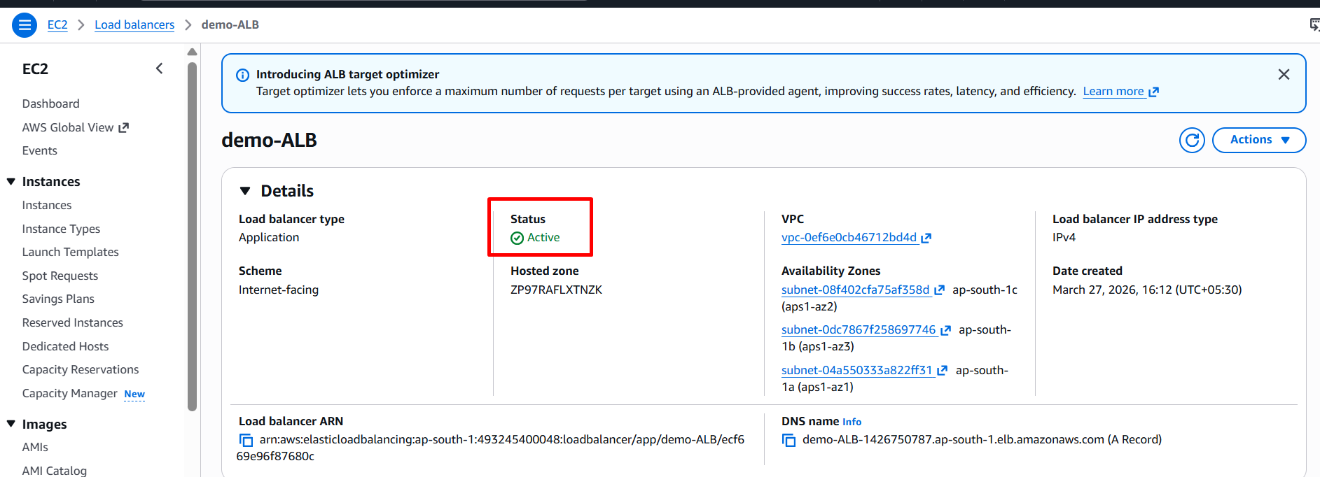
- Check the DNS name in browser
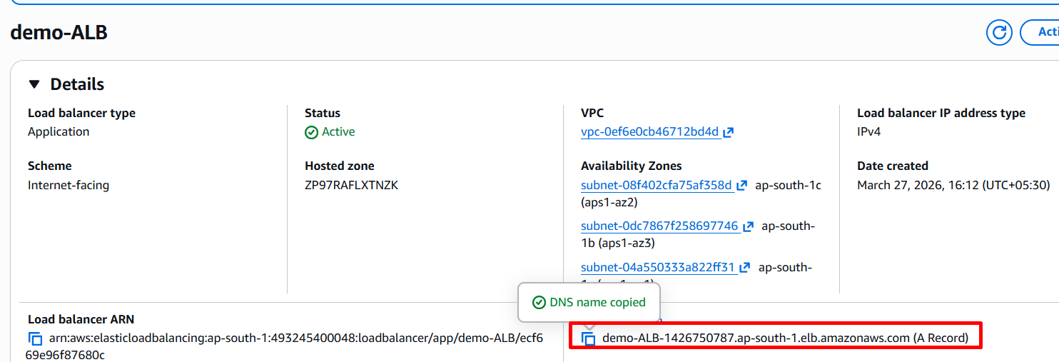
- Check the browser – It is shows first instance ip address
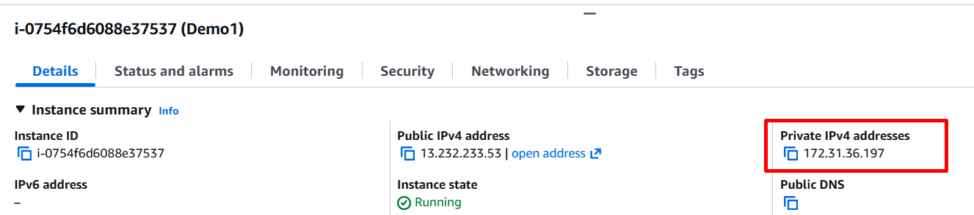



- Refresh the browser – It’s shows second instance Ip address
